
CERTIFICATE OF LOAD RESTRAINT COMPLIANCE
Wednesday, 8 May 2013

VEHICLES CAPABLE OF CARRYING BALES ON END THREE WIDE INCLUDING OVER-WIDTH CURTAIN-SIDED SEMITRAILERS AND B-DOUBLES, WITH UN-RATED CURTAINS CARRYING HIGH DENSITY (HD) COMPRESSED COTTON BALES – LOADS UNDER THE MANAGEMENT OF MEMBERS OF THE AUSTRALIAN COTTON GINNERS' ASSOCIATION ABN 26 375 354 115
John Lambert, Director of John Lambert & Associates Pty Ltd, a recognised expert in the design and evaluation of load restraint systems certifies that the SEMITRAILERS satisfying the requirements detailed below comply with the Performance standards detailed on page 186 of the Load Restraint Guide - Second Edition 2004 for the load arrangements given below provided the load complies with ALL stated conditions.
- The unrated Curtain assembly consists of an upper roller set running in the top curtain track, standard curtain webbing attached to the roller assembly, a webbing buckle used to pretension the webbing, a lower section of standard webbing and an end hook assembly. At a minimum the roller sets fail at 800 kg, the webbing fails at 1200 kg and has a 12% stretch at 600 kg, and the buckle and end hooks fail at 650 kg. These are the minimum ratings observed in tests undertaken by Polyweld Pty Ltd and John Lambert.
- The side opening of the semitrailer is up to 2800 mm (distance from top of tray to underside of the roof beam)
- The vehicle design, strength of the roof, roof supports, and tray must reflect industry standards;
- The HD compressed cotton bales

Have dimensions of about 1080 mm by 850 mm by 550 mm

On average weigh about 227 kg; and

Are enclosed in a bale made from cotton material.
- Bales are placed directly on the trailer floor, or on other bales (second or higher layers);
- The curtain and all its components must be in good condition - webbing and buckles to comply with Section H of the Load Restraint Guide Second Edition 2004; no missing buckles, et cetera ;
- And the loads comply with the description below
- the bottom layer consists of rows of three regular bales side by side and on end;
- the second layer consists mostly of rows of two bales on their sides, with one restraint over the front row and then a restraint for very four rows after that row;
- the second layer may also have one bale on their side rows, or one bale on their face rows or two bales on their face rows, arranged to ensure whole layer blocked to front, with a restraint over the first and last bale of each group
- the third layer (if required) comprises rows of two bales on their face, with a restraint over the first row and over each two rows after that.
Compliance has been determined through testing the friction factors between bales and a steel floor plate floor, and between cotton bales, consideration of all modes of failure, testing of the webbing to determine force versus deflection relationships, analysis of the movement of loads and the forces generated, and application of John Lambert’s knowledge and skills in the area of load restraint. That work is based on an April 2013 report: Namoi Cotton cotton bale load restraint Final Report available from the author or Namoi Cotton Co-op phone 02 6752-4378..
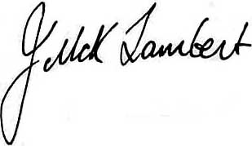 | MIEAust, CPEng 180 785  Bachelor of Engineering (University of Melbourne), ARMIT (Mechanical)  Director and Company Secretary, John Lambert & Associates Pty Ltd  ACN 090 833 873 ABN 59 090 833 873
A COPY OF THIS CERTIFICATE MUST BE CARRIED ON ANY TRUCK CLAIMING COMPLIANCE WITH LOAD RESTRAINT REGULATION BASED ON THIS DOCUMENT
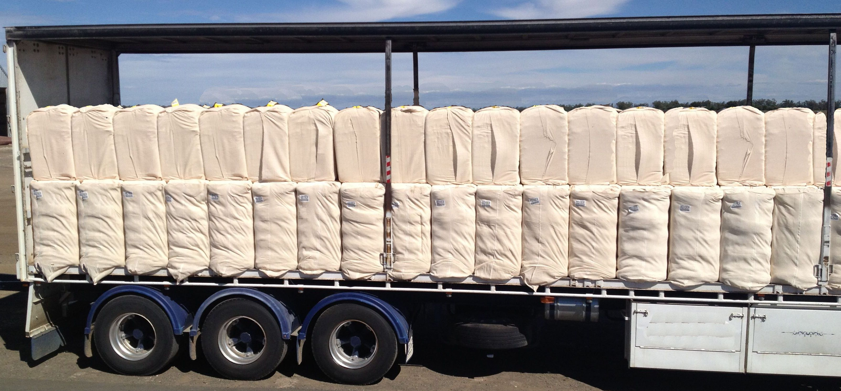
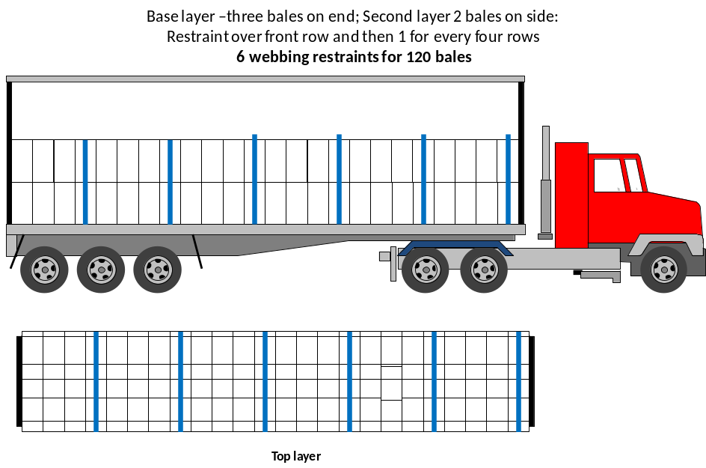
Arrangement with no gap at rear

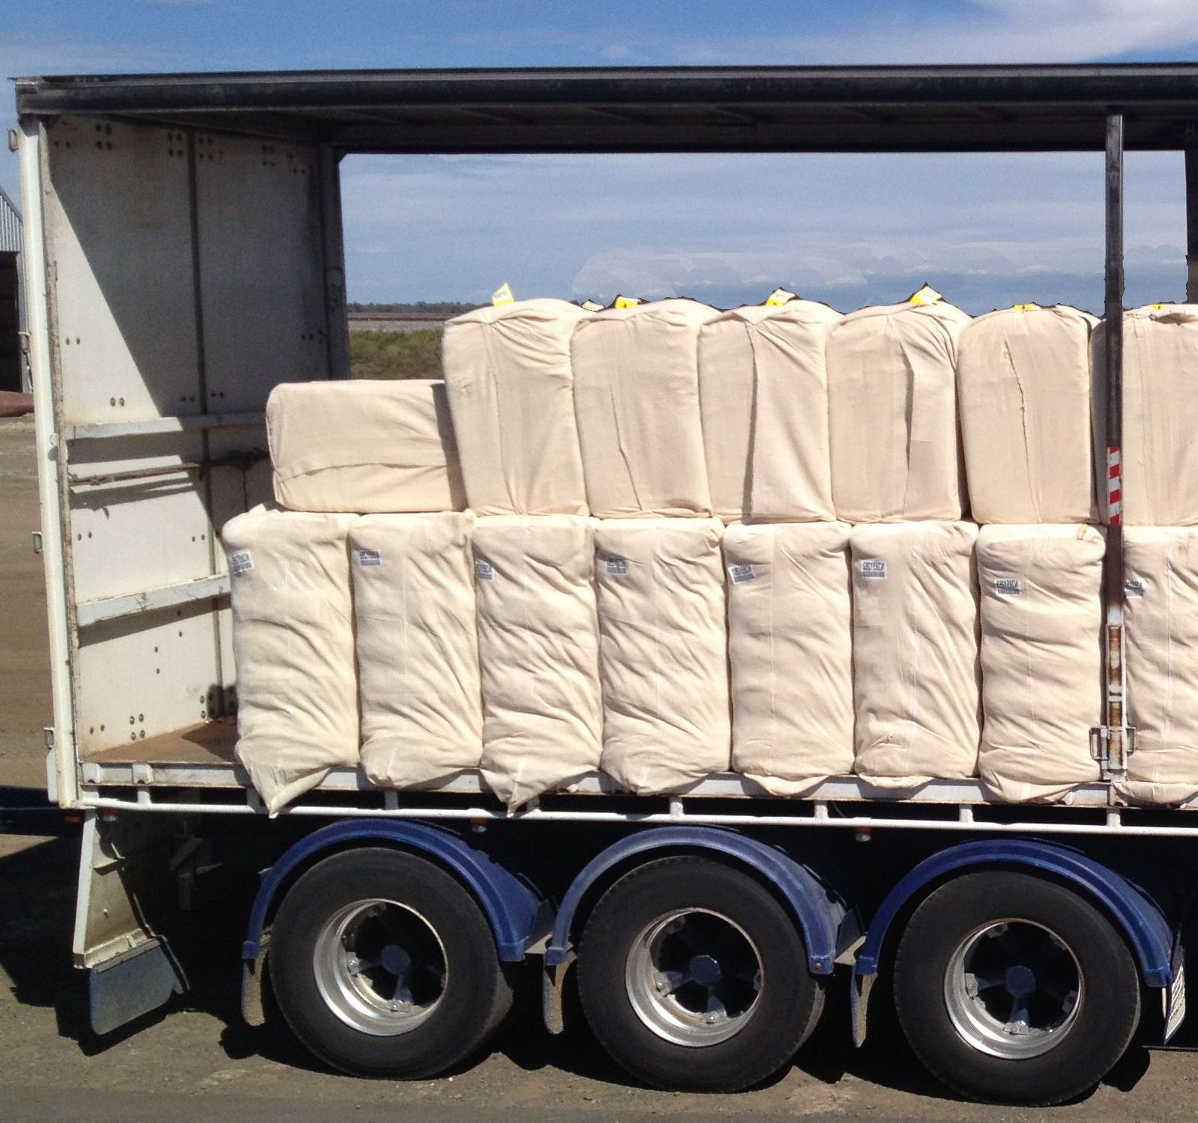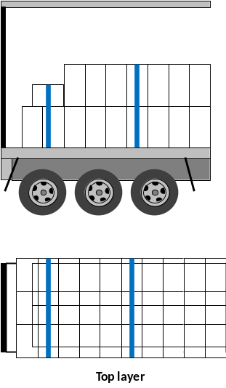
Arrangement with gap of greater than 300 mm at rear – place two bales face down across last two bottom rows and place a webbing restraint over the centre of the top bales
Arrangement to move weight over triaxle and avoid gaps >300 mm at rear.
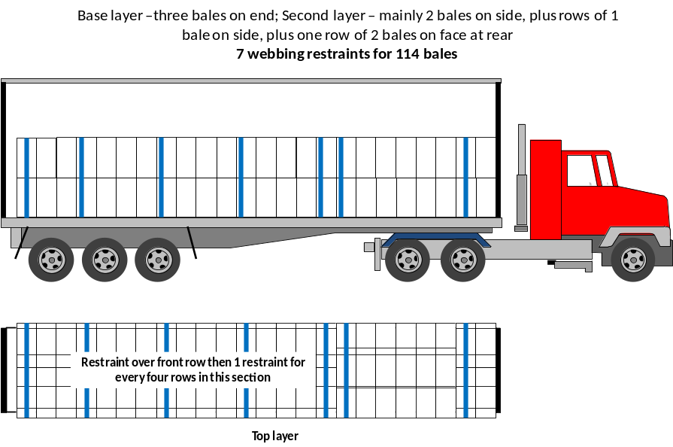
Arrangement to move further weight over triaxle and avoid gaps >300 mm at rear – for example with B-Double B trailer.


