Cotton Products Growers Video
Primary School Student Response Q&A

Before Viewing
Do you know where cotton comes from? YES/NO
Does cotton come from a plant, an animal or is cotton a man-made fibre?
List products you know are made using cotton in the table below.
Cotton in our clothes | Cotton in our homes | Cotton in other products

Watch Video https://www.youtube.com/watch?v=3TW3osxL1fM
After Viewing
Does cotton come from a plant, an animal or is cotton a man-made fibre?
List more cotton products you have discovered come from cotton after watching the video in the table below.
Cotton in our clothes | Cotton in our homes | Cotton in other products

Six cotton growers from New South Wales and Queensland are featured in the video. Write one fact you learnt from them next to their photo.
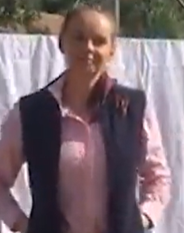
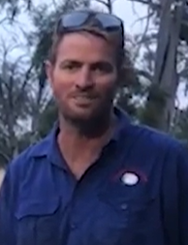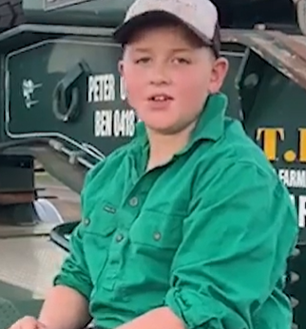
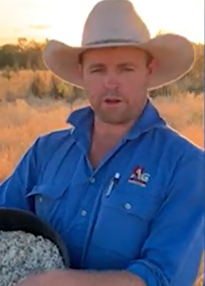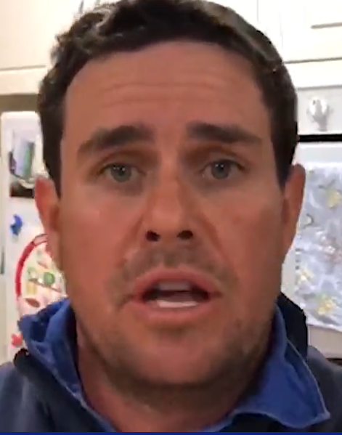
Write one thing about cotton you would like to know more about.

